Mustardo

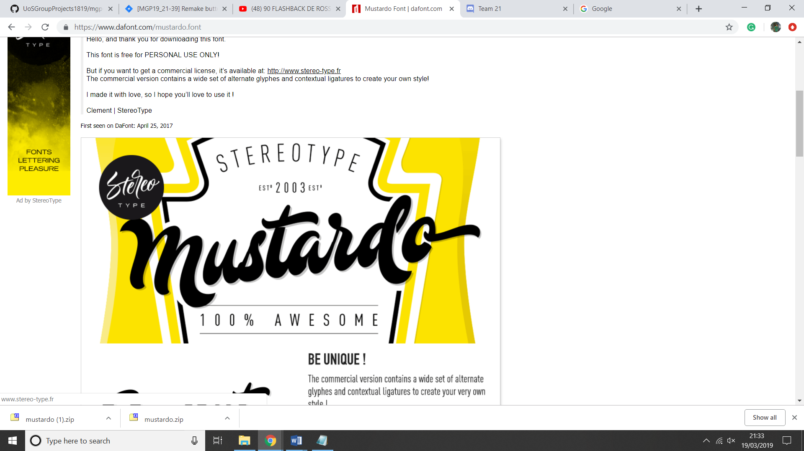

<https://www.dafont.com/mustardo.font>

hestina

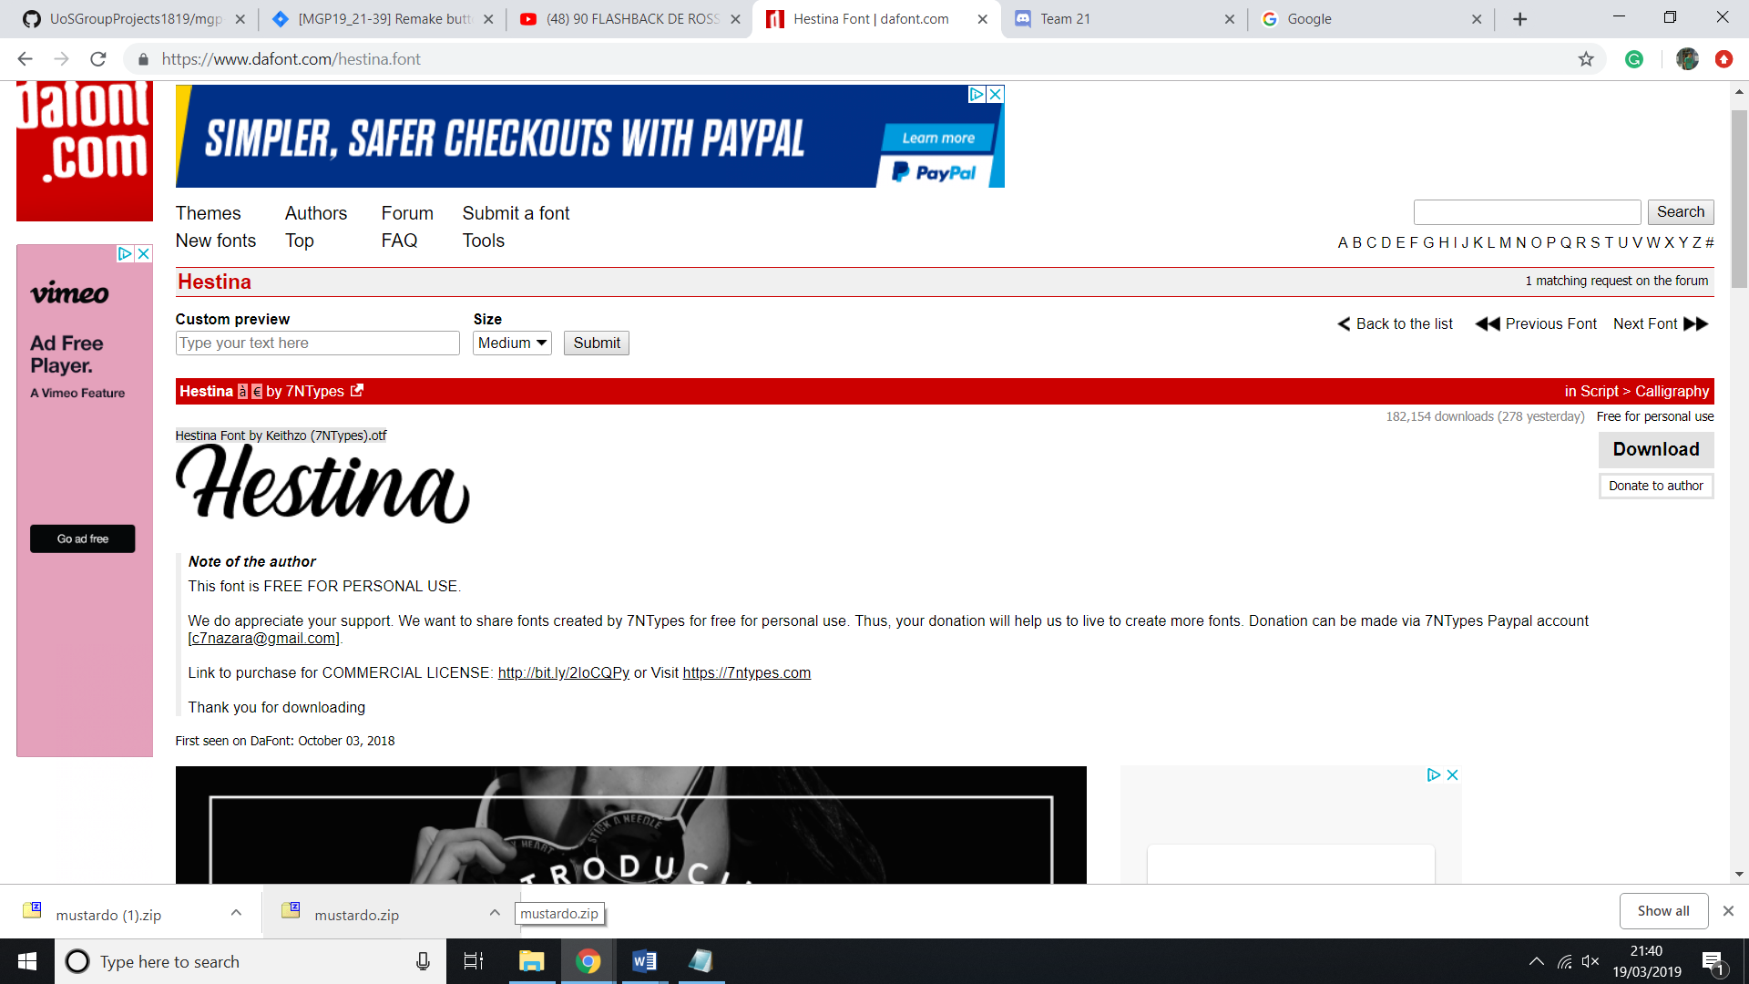

<https://www.dafont.com/hestina.font>

Brotherhood script

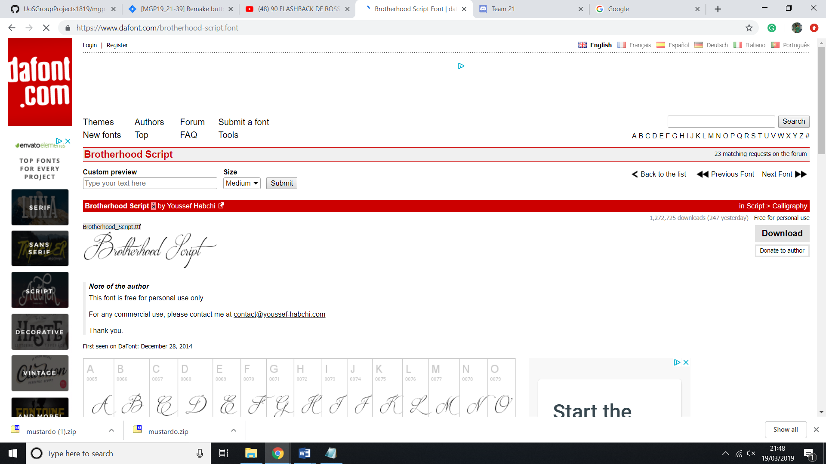

<https://www.dafont.com/brotherhood-script.font>

Clarissa

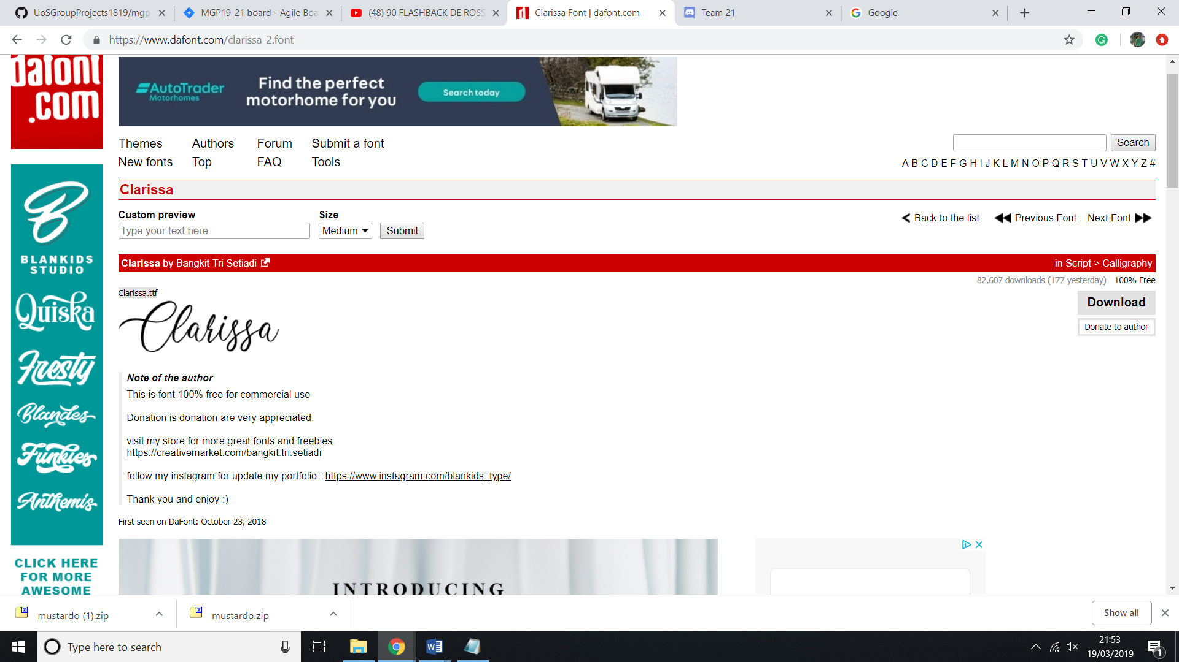

<https://www.dafont.com/clarissa-2.font>